# A. Introduction (Pendahuluan)

The manuscript is organized into seven main sections: Introduction, Methods, Result and Discussion, and Conclusion. Then followed by Acknowledgments (if any) and References. Article content may be written in Indonesia with sections Pendahuluan, Metode, Hasil dan Pembahasan, Kesimpulan followed by Ucapan Terimakasih (Jika Ada) and Daftar Pustaka.

Introduction section mainly contains research problems, facts / theories, gap analysis, solutions to problems, linkages / relevance to problems, recent research, research novelty, studies of main theories, and research objectives. This section sometimes contains expectations for the results (research hypotheses) and benefits of the research. The introduction is typed with one space.

The body of text uses the following fonts: Book Antique 11, space 1, spacing before 0 pt, after 0 pt. The minimum length of the manuscript is 5 pages and a maximum of 22 pages, including pictures and tables without attachments. If the manuscript pages exceed 22 pages, a fee will be charged for each additional page. The manuscript is typed using the Microsoft Office Word Processor (.doc / .docx). Manuscripts are written on A4 paper format.

# B. Method (Metode)

## 1. Method A

This section contains methods only, it can contain charts or flowcharts. This section describes how the research was conducted. The main material of this section is the types of research methods used, the data collection instruments / techniques that are fully disclosed and their methods, the form of instruments, and the research subjects that are described in full. For research using tools and materials, it is necessary to write down the specifications of the tools and materials. Tool specifications describe the sophistication of the tools used while material specifications describe the types of materials used.

## 2. Method B

For qualitative research such as classroom action research, ethnography, phenomenology, case studies, and others, it is necessary to add the presence of researchers, research subjects, informants who help along with ways to explore research data, location and length of research and a description of the checking the validity of the research results.

# C. Result and Discussion (Hasil dan Pembahasan)

## 1. Result A

The result and discussion section contains the results of data analysis and discussion by linking research results with other research. This section is the main section of research article and is usually the longest section of the article. The research results presented in this section are “clean” results. The author does not need to present data analysis processes such as statistical calculations and hypothesis testing processes. Only the results of analysis and the results of hypothesis testing need to be reported. Tables and graphs can be used to clarify the presentation of research results verbally. Tables and charts should be commented on or discussed

## 2. Result B

The result and discussion section contains the results of data analysis and discussion by linking research results with other research. This section is the main section of research article and is usually the longest section of the article. The research results presented in this section are “clean” results. The author does not need to present data analysis processes such as statistical calculations and hypothesis testing processes. Only the results of analysis and the results of hypothesis testing need to be reported. Tables and graphs can be used to clarify the presentation of research results verbally. Tables and charts should be commented on or discussed

### a. Result B (1)

The result and discussion section contains the results of data analysis and discussion by linking research results with other research. This section is the main section of research article and is usually the longest section of the article. The research results presented in this section are “clean” results. The author does not need to present data analysis processes such as statistical calculations and hypothesis testing processes. Only the results of analysis and the results of hypothesis testing need to be reported. Tables and graphs can be used to clarify the presentation of research results verbally. Tables and charts should be commented on or discussed

### b. Result B (2)

The result and discussion section contains the results of data analysis and discussion by linking research results with other research. This section is the main section of research article and is usually the longest section of the article.

## 3. Result C

The result and discussion section contains the results of data analysis and discussion by linking research results with other research. This section is the main section of research article and is usually the longest section of the article. For qualitative research, the results section contains detailed sections in the form of sub-topics that are directly related to the research focus and categories. The discussion in the article aims to: (1) answer the problem formulation and research questions; (2) shows how the findings were obtained; (3) interpret findings; (4) linking research findings with existing knowledge structures; and (5) generating new theories or modifying existing theories.

In answering the research questions and problems, the research results must be concluded explicitly. The interpretation of the findings is carried out using existing logic and theories. Findings in the form of reality in the field are integrated / linked with previous research results or with existing theories. For this purpose there must be a reference. In generating new theories, old theories can be confirmed or rejected, some may need to modify the old theories.

In an article, sometimes it is inevitable to organize the writing of research results into "sub-headings". The following is how to write the organizational format, in which it shows how to write specific things that cannot be separated from an article.

Supporting instruments can be in the form of pictures (photos / graphs / charts) or tables. The figure / table must be given a serial number and a brief description with the format; centered, Book Antique 11, space 1. The contents of the table should be written in Book Antique 11 format, space 1. Information on pictures / tables are not allowed to be similar to one another.

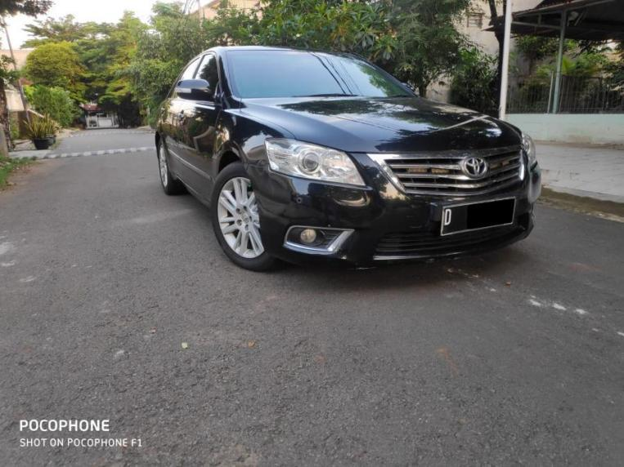

**Figure 1:** Example of a figure 1

**Table 1**: Standard table format 1

| **Head of Table** | **Column 1** | **Column 2** | **Column 3** |
| --- | --- | --- | --- |
| Line 1 | Text | Text | Text |
| Line 2 | Text | - | - |
| Line 3 | Text | - | - |
| Line 4 | Text | - | - |

Each figure / table must be accompanied by a brief narrative that refers to the number of the figure / table in question. Image / table files are included in separate folders with .jpg / .jpeg format (150-300 dpi).

# D. Conclusion (Kesimpulan)

Closing is written to direct the reader to important things that are not superficial and narrow. The conclusion consists of two parts, conclusions and suggestions. The conclusion provides a summary of the description of the results and discussion in general, refers to the research objectives, and links the results of research in the field. Based on these three things, new ideas are developed which are the essence of the research findings.

Suggestions are compiled based on the research findings that have been discussed. Suggestions can refer to practical action, development of new theories, and / or follow-up research.